OPENING

IN THIS MODULE, WE’LL FOCUS ON:
- Getting oriented to this course and to each other.
- Exploring what change means to you.
- Understanding the current environment of change at SCE.

VIEW OF CHANGE
- How does this card signify
CHANGE to you?
- What do you see in this card?
- What do you feel from this card?

THE CASE FOR CHANGE (Video)
(Take notes while you watch the video)

INSIGHTS & AHAS

UNDERSTANDING CHANGE

IN THIS MODULE, WE’LL FOCUS ON:
- Exploring past situations that involve change.
- Describing your typical reactions to change, especially a difficult change.
- Describing the phases of change.

TWO CHANGE SCENARIOS
- Describe a past change that was difficult to accept.
- Describe a past change you openly welcomed.

REACTIONS TO A DIFFICULT CHANGE*
- Briefly describe the change from the past that was difficult for you to accept. | [Use scenario 1 on the previous page. Record your
 | partner’s key words and phrases on the lines below.]
- What were things like BEFORE you were aware that this change would be taking place?
- When you realized this change would be taking place, how did you feel at first?
- What was it like for you as you BEGAN to experience or make the change?
- As you continued to experience the change and could see the end in sight, what did THAT feel like?
- How did you feel AFTER the change was complete?
THE EMOTIONAL CHANGE CURVE
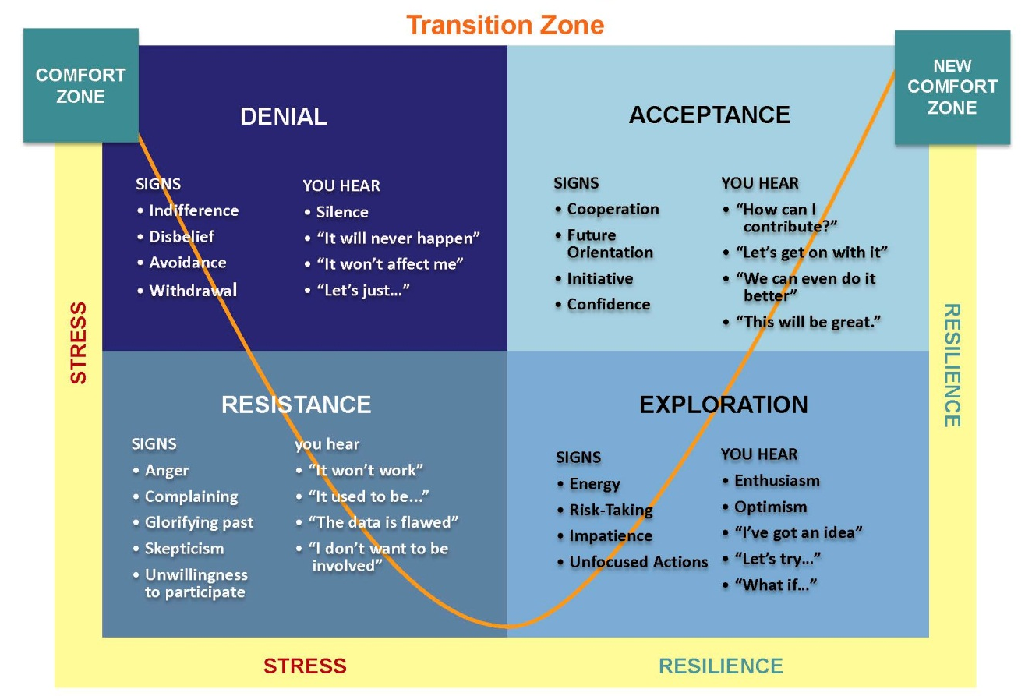(Adapted from Kubler-Ross)

Comfort Zone | This is the stage of familiarity and comfort. It’s business as usual.
Denial | This is a stage of shock that occurs when we need to keep functioning and are trying to make sense of the news. We may be immobilized or even be in denial that this change will really impact us.
Resistance | Resistance naturally occurs when we realize that the change is real and we begin to recognize or anticipate loss or fear about what may happen to us. It can manifest itself as opposition or defiance, and it can be active (out in the open) or passive (behind the scenes).
Exploration | As humans we are naturally resilient. In the EXPLORATION stage, we begin to test options to see if we can make the change work for us.
Acceptance | At this stage, we’ve accepted the fact of the change, and our focus begins to move forward toward the future. We are ready to face the future.
New Comfort Zone | This is the stage of newfound familiarity and comfort. Once again, it’s business as usual.
INSIGHTS & AHAS

THE EMOTIONS OF CHANGE

IN THIS MODULE, WE’LL FOCUS ON:
- Describing the emotions related to change and stress.
VIDEO: Dr. Joseph Dadourian, Ed.D. speaks about change, emotions, and stress. Dr. Dadourian is a Licensed Clinical Psychologist specializing in stress management, change management, and threat assessment and intervention. He is associated with the SCE Employee Assistance Program – Horizon EAP.

PRIMARY WORKPLACE RESPONSIBILITIES
 | Performance | Conduct
 | Projects  Assignments  Duties  Deliverables | Behavior  Respectful and  Professional  Communication  Interactions

CHANGE AND STRESS
- Self-Awareness: Acknowledge your feelings, thoughts, and behavior about the change. Listen to yourself.
- Other Awareness: Understand that others may be going through a change too.
- Emotional Management: Manage your feelings in a professional and productive manner. Keep your emotions from negatively impacting behavior.

STRESS AND DISTRESS
Stress is:
- A normal and natural response to change, challenges, or threats.
- A mobilization of the body’s defenses to deal with changes and threats.
- An increase in adrenaline to help you rise to the occasion.

Distress is:
- When stress is too intense or prolonged.
- Dangerous to your health.

What is stressful for one person may not be for another.

THE BRAIN AND EMOTIONS

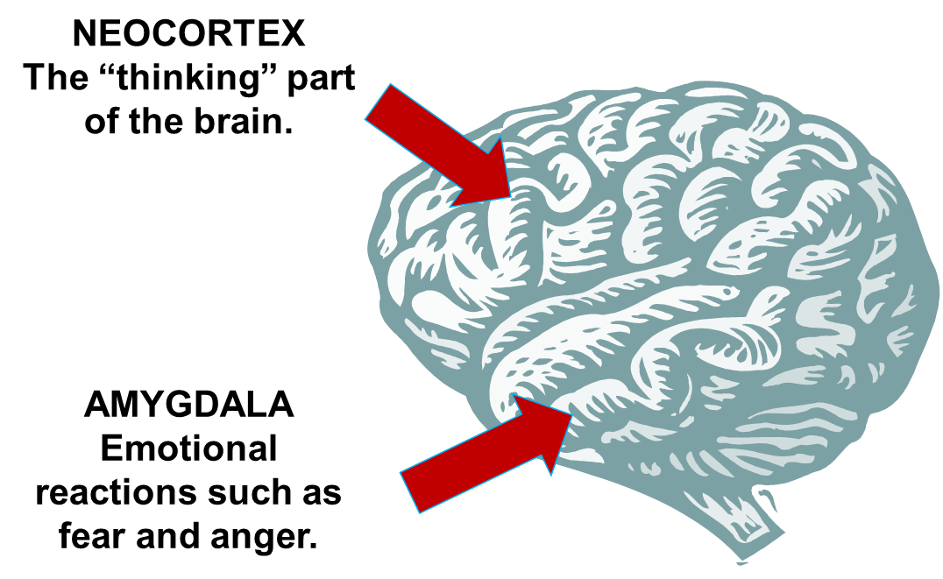

An Amygdala Attack
- Rational thinking stops
- Impulses override rationality
- Worry, anxiety, panic and fear take over
- Knee-jerk reactions happen
- Hyper-vigilance occurs
BASELINE RESPONSES TO CHANGE
 | PHYSICAL | EMOTIONAL
 | Increased heart rate  Tightness of chest  Difficulty breathing  Sweaty palms  Headache  Grinding teeth  Urinary changes  Diarrhea  Sleep disturbance | Fear/anxiety/insecurity  Irritability  Angry outbursts  Feelings of worthlessness  Depression  Suspiciousness  Jealousy  Hopelessness  Withdrawal  Tendency to cry  Feeling victimized
 | THINKING/PERCEPTION | BEHAVIORAL
 | Interferes with learning  Personalizing or against me  Gloom and doom thinking  Hyper vigilance or suspicion  Forgetfulness or confusion  Preoccupation or rumination  Lack of concentration  Lack of attention to details  Past orientation instead of future orientation  Lack of situational awareness  Reduction in interest | Performance and conduct  Anger outbursts  Blaming  Loss of motivation  Complaining/grievances  Withdrawal and isolation  Inappropriate humor  Increased carelessness or accidents  Gossip and rumors  Sarcasm or cynicism  Hostile compliance  Over-reaction or under-reaction

YOUR VIEW OF CHANGE

“Men are disturbed not by things, but the view which they take of them.”
(Epictecus, 1st Century)

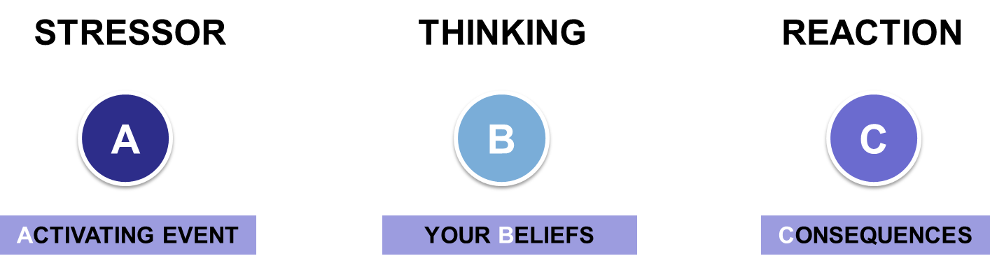

WE MANAGE OUR EMOTIONS
- When an animal is threatened, it has an INSTINCTIVE reaction.
- When a human is stressed, we can control our reactions by focusing on our beliefs.
- Emotional management is managing your feelings in a productive manner without being hijacked by them.

REFRAMING STRATEGIES
- Re-evaluate the old ways.
- Avoid “awful-izing.”
- Avoid negative thinking.
- See failures as new opportunities.
- Stay in the present. Focus on what needs to be done now.
- Be compassionate with yourself and others.
- Challenge the “should” and avoid thinking or saying “we used to do it this way.”
- Be inventive.

UNHEALTHY STRESS MANAGEMENT BEHAVIORS
- Overeating
- Drinking or drug-use
- Outburst of anger or violence
- Shopping
- Gambling

TIPS FOR MANAGING STRESS
- Exercise/physical activity
- Stretching/massage/yoga
- Relaxation/breathing
- Healthy nutrition
- Clarify goals/visualization
- Establish a support system
- Express your thoughts and feelings
- Avoid over-commitment
- Identify what you can control and what you can’t
- Translate worry into challenges, so you can deal with them
- Realize you’re not perfect
- Practice forgiveness, self-compassion and kindness
- Laugh more
- Get enough sleep
- Express gratitude for what you have
What about the additional job aids we have in the Leading Part. Wkbook? Negative Thinking, Conflict Management Tips?

INSIGHTS & AHAS

MINDSET AND RESILIENCE

IN THIS MODULE, WE’LL FOCUS ON:
- Distinguish between a victim mindset and a growth mindset.
- Describe the dynamics of resilience.
- Identifying resilience-building strategies.

VICTIM VS. GROWTH MINDSET
- What are the characteristics of a
VICTIM mindset?
- What are the characteristics of a
GROWTH mindset?

WHAT WAS YOUR MINDSET?
Reflect on your difficult change situation and answer the following questions:
- When you experience a difficult change, are you more likely to take on the victim mindset or the growth mindset?
- How would a victim mindset affect your experience of a difficult change?
- How would a growth mindset affect your experience of a difficult change?
NOTES
WHAT WOULD YOU DO?
- Your job description is changing and your work is being restructured. 50% of your new job involves tasks that you’ve never done before, and you aren’t sure if you have the right skills to do them.
- You are being merged into a new workgroup. You have been in your current group for 5 years, and you are very comfortable there. In the new group, you will have a new manager and you won’t know any of the other employees.

WHAT WOULD YOU DO? (cont’d)
- Your workgroup is being moved to a new location that is 20 miles farther from your home than the current location. The move happens in 4 weeks.
- You’ve heard through the grapevine that layoffs are coming, and your workgroup is being targeted.

RESILIENCE
- The capacity to remain flexible and strong in the midst of ambiguity, stress, and change.
- Remaining calm and balanced in unpredictable environments.
- Finding a way to keep moving forward in spite of obstacles and stressors.

Positive: | View life as challenging but opportunity filled.
Focused: | Maintain a clear vision of what is to be achieved.
Flexible: | Remains pliable when responding to uncertainty.
Organized: | Applies structure to help manage ambiguity.
Proactive: | Engages in change instead of avoiding it.

HOW TO INCREASE RESILIENCE
INCREASE SELF-AWARENESS:
- Tune into your physical sensations, emotions, thoughts, and behaviors.
- Reflect on your experiences.
- Recognize gut feelings and hunches.
- Talk about feelings and obtain feedback.

IMPROVE YOUR GROWTH MINDSET:
- Shift perceptions and beliefs from a “pessimistic” outlook to an “optimistic” point of view.
- View change as an opportunity and understand the need for change.
- Focus on learning, reframing negatives into positive.
- Try out new ways of doing things.
- “People are made, not born.”

HOW TO INCREASE RESILIENCE, cont’d
PRACTICE POSITIVE COMMUNICATION:
- Ask questions in a positive way.
- Deal directly with things that bother you.
- Speak at the right time, to the right person, in an appropriate manner.

FOLLOW THESE RECOMMENDATIONS:
- Identify what you can control
- Know that things are temporary
- Be honest about your feelings
- Keep healthy
- Manage stress
- Seek balance
- Nurture relationships
- Set goals
- Be kind and forgiving to yourself
- Laugh

INSIGHTS & AHAS

RESOURCES

IN THIS MODULE, WE’LL FOCUS ON:
- Identifying available stress-management and resilience-building resources and strategies.

RESOURCES I WILL TAKE ADVANTAGE OF:
- Employee Assistance Program
- Stress Management
- Resilience
- Books and Audio

RESOURCES | EMPLOYEE ASSISTANCE PROGRAM

HORIZON EMPLOYEE ASSISTANCE PROGRAM (EAP)
EAP Online @ www.horizoncarelink.com
EDISON's Employee Assistance Program (services provided through Horizon Health) provides you and your eligible dependents with confidential access to resources and services to help you live and work well. To access any of the services below through Horizon, simply call 1-800-443-4474.
The following benefits are provided to Edison International employees at no cost. These benefits are prepaid for you by Edison, so there is no charge when using these services.
- EAP Assessment & Referral
- WorkLife Resource & Referral
- Financial Services
- Legal Services
- Identity Theft

EAP Assessment & Referral
The EAP Assessment & Referral provides you and your eligible dependents with confidential counseling, available 24 hours a day, 365 days a year, on such issues as difficulties in relationships, emotional or psychological challenges, stress and anxiety with work or family, alcohol or drug abuse, and grief.
What types of services are covered?
- 5 face-to-face counseling sessions per incident.
- At a convenient time and location
- With a licensed clinician
- No copays
WorkLife Resource & Referral
Horizon Health provides you with immediate assistance in identifying real solutions for a host of personal and family issues. Horizon Health WorkLife Counselors can provide you with comprehensive referrals for a range of services. Edison pays the cost for referrals provided. You are only responsible for fees associated with the services you select.
What types of services are covered?
- Child care resources
- Elder care & care for people with disabilities
- Caregiver support
- School & College Planning
- Convenience Services
- And More!
Financial Services & Consultation
You can receive a consultation with a certified public accountant, financial planner, budget specialist, or licensed securities broker.
The initial assessment and 30 minutes of counseling are free. Further consultation is provided at a reduced hourly rate for each separate matter.
What types of services are covered?
- Tuition planning
- Investment planning
- Tax planning
- Debt and loan consolidation
- Mortgage and refinancing
- And more!

Legal Services & Consultation
Horizon Health can help you with a variety of legal questions.
The initial 30-minute office or telephone consultation is free for each separate legal matter. After the initial legal consultation, 25% discounted rates are available with a network legal provider.
What types of services are covered?
- Family / Domestic Law
- General-Civil
- Estate Planning
- Motor Vehicle
- Criminal
- And More

Identity Theft Program
Avoid identity theft and restore your identity and credit rating if you become a victim.
Horizon Health’s prevention tools can help you protect yourself and your family. However, in the unfortunate case of identity theft, our Fraud Resolution team immediately responds, coaching you through the process to repair your identity and credit.
Receive a free 60-minute telephone consultation with a trained Fraud Resolution Specialist. To access the Identity Theft Program through Horizon, simply call 1-800-443-4474.

RESOURCES | STRESS ASSESSMENTS

ASSESS YOUR STRESS – Part 1
Below you will find symptoms people experience when exposed to stressors. If you have experienced a symptom in the past two weeks, rate the severity of discomfort for this symptom by entering a number in the blank next to that particular symptom. Use the following scale to rate your discomfort level.

1
2
3
4
5
Slight Discomfort
Moderate Discomfort
Extreme Discomfort

 | PHYSICAL SYMPTOMS |  |  | EMOTIONAL SYMPTOMS
 | Muscle tension |  |  | Anxiety
 | Headache |  |  | Overwhelmed
 | Trembling |  |  | Frustration
 | Racing Heart |  |  | Anger
 | Rapid Breathing |  |  | Fragility
 | Diarrhea |  |  | Tearfulness
 | Stomach Cramps |  |  | Loss of interest
 | Nervous Stomach |  |  | Numbness
 | Sleeping Difficulties |  |  | Emotional Withdrawal
 | Fatigue |  |  | Other: _____________
 | Change in Eating Habits
 | Blemishes |  |  | COGNITIVE SYMPTOMS
 | Chest Pains |  |  | Difficulty Concentrating
 | Chronic Illness |  |  | Negative Thoughts
 | Increased Alcohol/Drug Use |  |  | Obsessive Thoughts
 | Increased Smoking |  |  | Memory Impairments
 | Vulnerable to Illness |  |  | Confusion
 | Other: _____________ |  |  | Other: _____________

CONSIDER:
- Have you selected several symptoms?  - Which ones are rated the most severe? | - Which three symptoms do you need to address first?  - Which symptoms do you feel READY to address first?
ASSESS YOUR STRESS – Part 2
DO YOU DO ANY OF THESE? You may be creating stress for yourself by…
- Worrying about situations you can't control.
- Failing to see choices and opportunities that are in front of you.
- Being a “professional procrastinator.”
- Being perfectionistic.
- Being inflexible or rigid.
- Being constantly competitive by seeing situations as win-lose.
- Being self-critical - focusing on faults vs. strengths.
- Failing to set limits or say “No.”
- Engaging in poor self-care (less sleep, eating poorly, stopping exercise, drink/smoke more when stressed).
- Expecting all problems should be neatly resolved.
IF YOU ARE EXPERIENCING STRESS:
- Determine your locus of control by completing the LOCUS OF CONTROL EXERCISE on the next page. It will help you identify the parts of your situation that are WITHIN your control, and the parts that are OUTSIDE of your control.
- Then review the STRESS MANAGEMENT STRATEGIES on the pages that follow.

LOCUS OF CONTROL EXERCISE
EXERCISE: Write in the appropriate areas the aspects of your situation that are WITHIN your control and OUTSIDE of your control. Be as honest as you can.
OUTSIDE OF MY CONTROL
WITHIN MY CONTROL

There’s a difference between WANTING to control something and actually being ABLE to control it. When you become aware of what you do not have control over, you can let go of those things and focus, instead, on the things you do have control over. When you do this, you will notice that your stress is reduced.
Adapted from: McKay, M., Davis, M. and Fanning P. Thoughts & Feelings, New Harbinger Publications: CA 1981
RESOURCES | STRESS MANAGEMENT STRATEGIES

WORKPLACE PRODUCTIVITY
STRATEGIES:
- Organize your work. Write “to do” lists, set priorities, and revise your list as needed.
- Write it down. Don't overburden your memory.
- If you are working on a time limited or detailed project, restrict telephone calls by having them held or sent to voicemail.
- Consider using uninterrupted blocks of time for big jobs or a collection of small jobs.
- Determine if tasks or projects can be shared or if parts can be delegated to others.
- Be assertive and clear regarding what is expected of you and ask for feedback.
- Be pro-active. Directly confront, resolve, or mediate a troubling or frustrating situation.
- Take responsibility. Do not blame others or assign fault, but look to see how a job can get done after a setback.

PHYSICAL ACTIVITY
STRATEGIES:
- Assess your fitness level before you start. Don’t push beyond your level – this can cause injury.
- Set realistic goals and write them down.
- Choose a plan that’s right for YOU – not what someone else thinks you should do.
- Build activity into your daily routine – take steps instead of elevators, park farther away, get off your bus stop one stop earlier and walk.
- Start slowly and build gradually – listen to your body.
SUGGESTIONS:
- Walk, run, dance  - Exercise, ride a bike | - Gardening  - Stretch or take a yoga class
LIFE BALANCE
STRATEGIES:
- Monitor your work, rest, and recreation balance. Are changes needed?
- Optimize your health with good nutrition, exercise, sleep, and rest. Put yourself first!
- Take breaks. Walk around, stretch, get some water, meditate, and BREATHE!
- Develop with co-workers your own brand of happy hour, or celebrate birthdays or other events as a break in the routine.
- Identify stressors and develop strategies for managing your own stress responses.
- Ask yourself if your identity and self-worth are wrapped up in your work activities or work roles.
- Develop or pay attention to the variety of sources of gratification in your life, including family, friends, hobbies, spirituality, etc.
- Be assertive. Learn how to express differences, make requests, and say “NO” constructively. Setting boundaries to protect our time, emotional and financial resources is very important!
- Good nutrition improves mental functioning which can impact perception and help improve healthy emotional responses.
- Getting connected with others improves feelings of belonging and value which decreases feelings of isolation and loneliness which decreases the stress response.
- Spiritual exploration can contribute to a sense of well-being which can decrease stress making us more perceptive and effective!
NUTRITION SUGGESTIONS:
- Drink plenty of water  - Eat healthy meals, not junk food | - Avoid alcohol and other mind-altering substances
SOCIAL AND EMOTIONAL SUPPORT SUGGESTIONS:
- Don’t keep your thoughts and feelings bottled up - express them to someone you trust  - Establish a support system, and use it | - Avoid over-committing yourself; it’s okay to say no.  - Practice forgiveness, self-compassion, and kindness

LIFE BALANCE, cont’d
MINDSET SUGGESTIONS:
- Reframe difficulties as opportunities  - Realize you’re not perfect, but perfectly human  - Translate worry into challenges, and then deal with them directly  - Engage in activities that you enjoy | - Express gratitude for what you have  - Identify what you can control and what you cannot  - Set realistic and attainable goals,  and visualize achieving them  - Don’t isolate yourself
OTHER SELF-CARE SUGGESTIONS:
- Consider occasionally coming in earlier or staying later instead of taking your work home with you every night.  - Take your lunch break. You need food for energy to get through the day. Don't take your job with you on breaks.  - Get enough sleep | - Reduce the noise level if possible. Rugs or draperies can help in an office. Close the door, if you have one, when you need to focus and concentrate.  - Take a creative lunch break. How much of the city or area within lunchtime radius of your job have you ever explored?

10-SECOND STRESS RELIEVER
WHEN YOU FEEL STRESSED, IRRITATED OR ANXIOUS:
- Smile as you think, “my body doesn’t need this.”
- Close your eyes and picture yourself in a place you enjoy and slowly breathe in deeply 3 times.
- As you breathe out, think “I am calm.”
- Open your eyes as you think, “I can handle this.”
- Now approach the task or problem.

RESOURCES | RESILIENCE ASSESSMENTS

ASSESS YOUR RESILIENCE – Part 1
Below you will find five factors that are associated with resilience. The presence and consistency of each factor affects how resilient you are. When you are able to minimize stress and maximize resilience, you will have an easier time managing change.

1
2
3
4
5
Rarely
Often
Always

RESILIENCE FACTORS:
Use the 1-5 scale to identify how often each factor below is present for you:
 |  | Positive: | You view life as opportunity-filled, even when it is challenging.
 |  | Focused: | You maintain a clear vision of what is to be achieved.
 |  | Flexible: | You remain pliable when responding to uncertainty.
 |  | Organized: | You apply structure to help manage ambiguity.
 |  | Proactive: | You engage in change instead of avoiding it.

Now total your scores and compare the sum to the chart below:

20 - 25 = Higher Resilience. Keep up the good work.
15 - 19 = Medium Resilience. You have an opportunity to strengthen your resilience.
14 or less = Lower Resilience. It’s time to implement stress-management and resilience-building strategies.

Review the Stress Management Strategies in the previous section and Resilience Strategies on the following pages to keep your resilience high.

ASSESS YOUR RESILIENCE – Part 2
DO YOU DO ANY OF THESE? These are 10 grand illusions that silently undermine your resilience:
- All-or-nothing thinking. In this type of thinking, you're either a hero or a failure. Any small misstep marks you as a failure. This kind of thinking can lead to crippling perfectionism.
- Overgeneralization. Whenever something bad happens, it's bound to happen again and again. If somebody you've idealized turns you down for a date, for example, you feel certain that the next person will, too.
- The mental filter. You dwell on the downside of any situation while overlooking anything positive. If you're an editor, you may become obsessed with a typo that escaped into print rather than congratulating yourself for getting out a great issue.
- Diminishing the positive. In this kind of thinking, you tend to twist positive events into negative ones. If you just got a raise, for example, you may put yourself down for not getting a bigger raise.
- Jumping to conclusions. You become either a mind reader or a fortune teller -- whatever it takes to see trouble on the horizon. If a friend doesn't return a call, he secretly dislikes you. If you like your job, you'll probably lose it soon.
- The binocular trick. It's as if you're wearing special lenses that let you see everything blown out of proportion. Little problems become monstrous; major victories, trifling.
- Emotional reasoning. You believe mood reflects your true identity: You feel lousy because you are lousy.
- 'Should' and 'must' thoughts. You constantly remind yourself of things you should or must do. At the end of the day, you feel buried in guilt and shame. You may also dwell on things that other people should or must do, setting yourself up for frustration and bitterness.
- Labeling and mislabeling. You tend to equate your 'self' with what you do, and since everyone makes mistakes, over time you develop a negative self-image based on errors you've made. If you invested in a high-tech stock deal that blew up in your face, for example, you view yourself as a failure. Failure, loser, dummy: The labels stick. If you tend to label other people as well, you'll reap a lot of hostility.
- Personalization. You assume responsibility for anything that goes wrong, even when it's not your fault. Burns calls this line of thinking "the mother of guilt."

From Burns, D.D. (1999). The Feeling Good Handbook, Revised Edition. New York: Plume.

RESOURCES | RESILIENCE STRATEGIES

ENHANCING RESILIENCE
- Find a sense of purpose.
- Have a positive outlook.
- Take pleasure in small joys.
- Take an active approach to problem solving.
- Build relationships.
- Keep learning.
- Expect change.
- Do something; don’t complain.
- Care for yourself.
- Attitude is a choice.

IMPROVING YOUR MINDSET
- Shift perceptions and beliefs from a “pessimistic” outlook to an “optimistic” point of view.
- View change as an opportunity and understand the need for change.
- Focus on learning and reframing negatives into positives.
- Try out new ways of doing things.
- “People are made, not born.”

RESILIENT COMMUNICATION
COMMUNICATE PROACTIVELY AND POSITIVELY:
- Ask questions in a positive way.
- Deal directly with things that bother you.
- Speak at the right time, to the right person, in an appropriate manner. This is crucial for maintaining your own morale and the team morale.
RESILIENT COMMUNICATION, cont’d
DEMONSTRATE EMPATHY:
- Put yourself in the other person’s shoes.
- Project a sincere, empathetic attitude.
- Respond to feelings, not the content.
- Recognize that people have the right to their own point of view.
- Identify the concerns of the individual.
- Ask open-ended questions.
- Eliminate interrupting, assuming, judging.
- Paraphrase or state what you heard in your own words.

COMMUNICATE EMPATHETICALLY:
- Recognize presence of strong feelings in the other person.
- Pause to imagine how the person might be feeling.
- State your perception of the person’s feeling (i.e. "I can imagine that must be ..." or "It sounds like you're upset about ...") “Saying what you see.”
- Legitimize/validate their feelings.
- Respect the person's effort to cope with the predicament.
- Offer support and partnership (i.e. "I'm committed to work with you to ..." or "Let's see what we can do together to ...").

ASKING QUESTIONS WITH EMPATHY:
- Can you tell me more about that?
- What has this been like for you?
- How has all of this made you feel?
- How were you surprised by…?

RESILIENT COMMUNICATION, cont’d

CLARIFYING WITH EMPATHY:
- Let me see if I’ve gotten this right…
- Tell me more about…
- I want to make sure I understand what you’ve said…
- What can I do so you don’t feel so surprised…

RESPONDING WITH EMPATHY:
- Sounds like you are…
- I imagine that must be…
- I understand that must make you feel…
- I hear that you would like me to…

CONFLICT MANAGEMENT
- Analyze the conflict first - think before you speak.
- Understand the other person’s point of view.
- Say what you “see” --- not what you assume or interpret.
- Determine appropriate response and management style (e.g., collaborate, compromise, accommodate).
- Present your perspective of the problem and its impact.
- Use specific facts, be objective and nonjudgmental.
- Identify your feelings, desires, and needs.
- Use “I” statements.
- Use humor if possible.
- Don’t let emotions get in the way.
- Learn from previous conflict management failures.

RESOURCES | BOOKS AND AUDIO

BOOKS
TITLE |  | Author
- The 7 Habits of Highly Successful People: Powerful Lessons in Personal Change |  | Stephen R. Covey
- The Art of Possibility: Transforming Professional and Personal Life |  | Rosamund Stone Zander and Benjamin Zander
- Flourish: A Visionary New Understanding of Happiness and Well-Being |  | Martin E. P Seligman
- The Joy of Working: The 30 Day System to Success, Wealth, and Happiness on the Job |  | Dennis Waitley and Deni L. Witt
- Managing Transitions: Making the Most of Change |  | William Bridges
- Overcoming Job Burnout: How to Renew Your Enthusiasm for Work |  | Beverly Potter
- The Path of Least Resistance: Learning to Become the Creative Force in Your Own Life |  | Robert Fritz
- Positivity: Groundbreaking Research Reveals How to Embrace the Hidden Strength of Positive Emotions, Overcome Negativity, and Thrive |  | Barbara Fredrickson
- Preventing Job Burnout |  | Beverly A. Potter
- The Relaxation & Stress Reduction Workbook |  | Martha Davis, Elizabeth Robbins, Matthew McKay, and Patrick Fanning
- Stress at Work: Management and Prevention |  | Jeremy Stranks
- The Stress Management Handbook |  | Lori Leyden-Rubenstein
- Thoughts & Feelings: Taking Control of Your Moods and Your Life (a Workbook of Cognitive Behavioral Techniques |  | Matthew McKay, Patrick Fanning, and Martha Davis
AUDIO TAPES
TITLE | Author
- Letting Go of Stress | Emmett E. Miller, M.D. and Steven Halpern, Ph.D.
- Relaxation & Inspiration | Emmett E. Miller, M.D.
- Enhancing Peak Performance | Steven Halpern, Ph.D.
- Effortless Relaxation | Steven Halpern, Ph.D.
- Ten Minutes to Relax – Volume One | Vital Body Marketing Company, Inc.
- Relaxation & Stress Reduction Cassette Tapes | Matthew McKay, Ph.D. and Patrick Fanning

CLOSING

IN THIS MODULE, WE’LL FOCUS ON:
- Reviewing what you learned.
- Evaluating your experience in this course.

DID THIS COURSE HELP YOU:
- Understand the stages of change?
- Explore your own tendencies when responding to change?
- Describe how your mindset matters, and how resilience is one of the keys to managing change?
- Explore strategies for managing stress and building resilience?
- Identify available resources that will help you respond to and manage change?

THE MOST IMPORTANT INFORMATION I LEARNED WAS:

QUESTIONS ABOUT THIS COURSE?
Send an email to BuildingChangeResiliency@sce.com if you have any questions or comments about this course.

